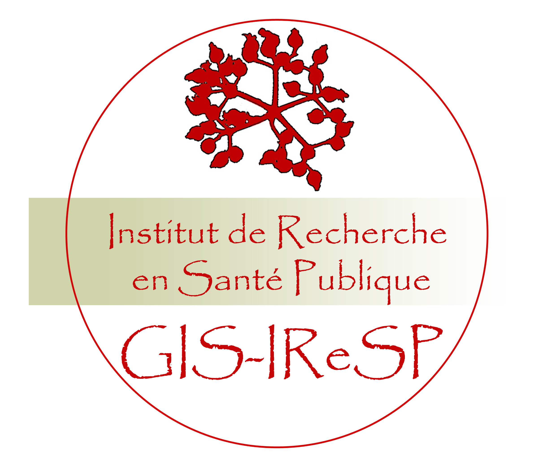

International symposium
« Cohorts and cancer research »

October 13, 2009
Venue : Institut Mutualiste Montsouris, Paris 14ème.

Preliminary programme
08:30 – 9:00: Registration
9:00 – 9:15: The French Epigramme cohort database
Nathalie de Parseval (IReSP), Marie-Josèphe Saurel (IReSP)
9:20 – 10:50: Session 1 – Genetics (Chair : Gilles Thomas)

- Use of prospective cohorts in the GWAS era. (David Hunter, Boston, USA)
- How could the susceptibility loci identified by GWAS best used for cancer prevention or early detection? (Paul Pharoah, Cambridge,UK)
- Towards a new Canadian prospective study on cancer. (John McLaughlin, Toronto, Canada)
11:00 – 11:15: coffee break
11:15 – 12:45 : Session 2 – Epidemiology and Environment (Chair : Denis Hémon)

- The European Prospective Investigation into Cancer and Nutrition. (Elio Riboli, Cambridge,UK)
- Investigating social disparities and health inequalities. (Archana Singh Manoux, Inserm, France)
- Epidemiology of childhood cancer: environmental factors and gene-environment interactions. (Jacqueline Clavel, Inserm, France)
13:00 – 14:00: Lunch (provided on site)
14:00 –16:00 : Session 3 – Cancer detection and comprehensive care (Chair : Guy Launoy)

- Cohorts of occupational exposed subjects, cancer surveillance and screening: the ARDCO study. (Jean-Claude Pairon, France)
- General population epidemiological data and banking of biological resources: which opportunities in France? (Jean Faivre, France)
- Assessment of benefit and adverse effects for cancer screening: Interest and pitfalls of cohorts and other study designs (Stephen Duffy, London, UK)
- Contribution of cohorts for the improvement of cancer care and follow up (Paolo Boffeta, IARC, France).
16:00 – 16:45 : Keynote lecture
Robert Hoover, NCI, Bethesda, USA
16:45 – 17:45: Round Table: What should be the strategic plans to reinforce cohort studies and cancer research in a national and European perspective: to ensure long term sustainability of existing cohorts; to establish new cohorts?
Fabien Calvo (INCa), Jacques Esteve , Martine Lequellec-Nathan (INCa), Alfred Spira (IReSP), Martin Guepereau or Gérard Lasfargue (Afsset)
17 :45 – 18 :00: Conclusion
Dominique Maraninchi (INCa), Gérard Bréart (Institut Inserm Santé Publique)

*************************************************************
Contact :
Valérie Thibaudeau, INCa, tel : 33 (0)1 41 10 15 76, vthibaudeau@institutcancer.fr

